# 

# **E & TC Department**

# **A.Y. 2021-22 Semester-II**

|  |
| --- |
| **Problem statement:** Design a static web page to demonstrate the use of different HTML tags.  **Date of Performance:** 28/02/2022.  **Theme:** L-Learning Webpage. |

# **ET-A Batch A1**

# **GROUP 6**

|  |  |  |
| --- | --- | --- |
| **Gr No** | **Roll No:** | **Name** |
| 11910109 | 3 | Anant Abhyankar |
| 12020074 | 16 | Ali Aslam |
| 11910008 | 25 | Ankush Chadgal |

1. **Home Page.**

**<**!DOCTYPE html>

<html lang="en">

<head>

<link rel="" href="solvent.png">

<meta charset="UTF-8">

<meta http-equiv="X-UA-Compatible" content="IE=edge">

<meta name="viewport" content="width=device-width, initial-scale=1.0">

<title>WT_Lab_1_Group_6</title>

</head>

<style>

</style>

<body>

<table id="header" border="0" width="100%" cellpadding="0" cellspacing="0" bgcolor="#35325">

<tr>

<td>

<table border="0" width="85%" cellpadding="15" cellspacing="0" align="center">

<tr>

<td>

<center>

<font face="Aharoni" color="#9999" size="7">

Web Development for Beginners

</center>

</td>

<td width="5%">

&nbsp;

</td>

<table id="header" border="0" width="100%" cellpadding="0" cellspacing="0" bgcolor="#sasas">

<tr>

<td>

<table border="0" width="85%" cellpadding="15" cellspacing="0" align="center">

<tr>

<td>

<font face="Aharoni" color="#9999" size="5">

</td>

<td width="18%">

&nbsp;

</td>

<td>

<a href="sample.html">

<font face="Aharoni" color="#FFFFFF" size="4">Home</font>

</color>

</a>&nbsp;&nbsp;&nbsp;&nbsp;&nbsp;&nbsp;&nbsp;&nbsp;&nbsp;&nbsp;&nbsp;&nbsp;&nbsp;&nbsp;&nbsp;&nbsp;&nbsp;

</a>

<a href="#">

<font face="Aharoni" color="#FFFFFF" size="4">About</font>

</color>

</a>&nbsp;&nbsp;&nbsp;&nbsp;&nbsp;&nbsp;&nbsp;&nbsp;&nbsp;&nbsp;&nbsp;&nbsp;&nbsp;&nbsp;&nbsp;&nbsp;&nbsp;

<a href="freecourses.html">

<font face="Aharoni" color="#FFFFFF" size="4">Courses</font>

</color>

</a>&nbsp;&nbsp;&nbsp;&nbsp;&nbsp;&nbsp;&nbsp;&nbsp;&nbsp;&nbsp;&nbsp;&nbsp;&nbsp;&nbsp;&nbsp;&nbsp;&nbsp;

<a href="Login.html">

<font face="Aharoni" color="#FFFFFF" size="4">Login/Sign</font>

</color>

</a>

</td>

</tr>

</tr>

</table>

</table>

<!-- End Header

Start Header -->

<table id="home" border="0" width="100%" cellpadding="0" cellspacing="0" bgcolor="#292929">

<tr>

<td>

<table border="0" width="85%" cellpadding="15" cellspacing="0" align="center">

<tr>

<td align="center" valign="middle">

<h3>

<font face="arial" color="#ffffff" size="6">

Hi, Welcome to our Website

</font>

</h3>

<h2>

<font face="arial" color="#f3971b" size="7">

Here you get All Study Materials

</font>

</h2>

</td>

</tr>

</table>

</td>

</tr>

</table>

<!--End Home-->

<!--Start About-->

<table id="about" border="0" width="100%" cellpadding="0" cellspacing="0" bgcolor="#292929">

<tr>

<td>

<table border="0" width="85%" cellpadding="15" cellspacing="0" align="center">

<!-- Heading Start-->

<tr>

<td height="180" align="center" valign="middle" colspan="2">

<font face="arial" color="#f3971b" size="6">

About

</font>

<hr width="70" color="#f3971b">

<br>

<font face="Aharoni" color="#f3971b1" size="4">

<a href="https://www.youtube.com/" target="_blank" rel="noopener noreferrer">

<a style="color: rgb(255, 217, 0);"> YouTube </a></a>&nbsp;&nbsp;|&nbsp;&nbsp;

<a target="_blank" rel="noopener noreferrer">

<a style="color: rgb(255, 217, 0);">LinkedIn </a></a>&nbsp;&nbsp;|&nbsp;&nbsp;

<a target="_blank" rel="noopener noreferrer"> <a style="color: rgb(255, 217, 0);">Instagram </a></a>

</font>

</td>

</tr>

<section>

<font face="arial" color="#ffffff" size="5">

<h2 align="center">Learn HTML For Beginners </h2>

</font>

<iframe width="620" height="315" src="https://www.youtube.com/embed/7mdEvKyLoYM" title="YouTube video player" frameborder="0" allow="accelerometer; autoplay; clipboard-write; encrypted-media; gyroscope; picture-in-picture" allowfullscreen></iframe>

<iframe width="620" height="315" src="https://www.youtube.com/embed/BsDoLVMnmZs" title="YouTube video player" frameborder="0" allow="accelerometer; autoplay; clipboard-write; encrypted-media; gyroscope; picture-in-picture" allowfullscreen></iframe>

<iframe width="620" height="315" src="https://www.youtube.com/embed/pQN-pnXPaVg" title="YouTube video player" frameborder="0" allow="accelerometer; autoplay; clipboard-write; encrypted-media; gyroscope; picture-in-picture" allowfullscreen></iframe>

<iframe width="620" height="315" src="https://www.youtube.com/embed/88PXJAA6szs" title="YouTube video player" frameborder="0" allow="accelerometer; autoplay; clipboard-write; encrypted-media; gyroscope; picture-in-picture" allowfullscreen></iframe>

</section>

<section>

<font face="arial" color="#ffffff" size="5">

<h2 align="center">Learn CSS For Beginners </h2>

</font>

<iframe width="620" height="315" src="https://www.youtube.com/embed/1Rs2ND1ryYc" title="YouTube video player" frameborder="0" allow="accelerometer; autoplay; clipboard-write; encrypted-media; gyroscope; picture-in-picture" allowfullscreen></iframe>

<iframe width="620" height="315" src="https://www.youtube.com/embed/3_9znKVNe5g" title="YouTube video player" frameborder="0" allow="accelerometer; autoplay; clipboard-write; encrypted-media; gyroscope; picture-in-picture" allowfullscreen></iframe>

<iframe width="620" height="315" src="https://www.youtube.com/embed/ieTHC78giGQ" title="YouTube video player" frameborder="0" allow="accelerometer; autoplay; clipboard-write; encrypted-media; gyroscope; picture-in-picture" allowfullscreen></iframe>

<iframe width="620" height="315" src="https://www.youtube.com/embed/yfoY53QXEnI" title="YouTube video player" frameborder="0" allow="accelerometer; autoplay; clipboard-write; encrypted-media; gyroscope; picture-in-picture" allowfullscreen></iframe>

</section>

<section>

<font face="arial" color="#ffffff" size="5">

<h2 align="center">Study Material</h2>

</font>

<a target="_blank" href="Basic_of_web.pdf"><img src="Basic_of_web.jpg" alt="" width="620" height="315"></a>

<a target="_blank" href="CSS.pdf"><img src="CSS.png" alt="" width="620" height="315"></a>

</section>

<section>

<font face="arial" color="#ffffff" size="5">

<h2 align="center">Books</h2>

</font>

<a target="_blank" href="BOOK1.pdf"><img src="BOOK1.png" alt="" width="33%" height="80%"></a>

<a target="_blank" href="BOOK2.pdf"><img src="BOOK2.png" alt="" width="33%" height="75%"></a>

<a target="_blank" href="BOOK3.pdf"><img src="BOOK3.png" alt="" width="33%" height="75%"></a>

</section>

<table id="header" border="0" width="100%" cellpadding="0" cellspacing="0" bgcolor="#35325">

<tr>

<td>

<table border="0" width="85%" cellpadding="0" cellspacing="0" align="center">

<tr>

<td>

<font face="Aharoni" color="#9999" size="4">

FAQ

</font>

</td>

<td width="20%">

&nbsp;

</td>

<td>

<a href="#">

<font face="Aharoni" color="#FFFFFF" size="4">Contact Us</font>

</color>

</a>&nbsp;&nbsp;&nbsp;&nbsp;&nbsp;&nbsp;&nbsp;&nbsp;&nbsp;&nbsp;&nbsp;

</a>

<a href="#">

<font face="Aharoni" color="#FFFFFF" size="4">Privacy Policy</font>

</color>

</a>&nbsp;&nbsp;&nbsp;&nbsp;&nbsp;&nbsp;&nbsp;&nbsp;&nbsp;&nbsp;&nbsp;&nbsp;

<a href="#">

<font face="Aharoni" color="#FFFFFF" size="4">Refund Policy</font>

</color>

</a>&nbsp;&nbsp;&nbsp;&nbsp;&nbsp;&nbsp;&nbsp;&nbsp;&nbsp;&nbsp;&nbsp;&nbsp;

<a href="#">

<font face="Aharoni" color="#FFFFFF" size="5">&copy; 2022</font>

</color>

</a>&nbsp;&nbsp;&nbsp;&nbsp;&nbsp;&nbsp;&nbsp;&nbsp;&nbsp;&nbsp;

</td>

</tr>

</tr>

</table>

</table>

</body>

</html>

1. **Login Webpage:**

<!DOCTYPE html>

<html lang="en">

<head>

<meta charset="UTF-8">

<meta http-equiv="X-UA-Compatible" content="IE=edge">

<meta name="viewport" content="width=device-width, initial-scale=1.0">

<title>Payment Form</title>

</head>

<body style="background-color: rgb(219, 219, 219);">

<form action="" method="">

<center>

<h1>Login Details</h1>

</center>

<p>Name: * <br><input type="text" name="name" required></p>

<fieldset>

<legend>Gender * <br></legend>

<p>

Male <input type="radio" name="gender" id="" required> Female <input type="radio" name="gender" id="" required>

</p>

</fieldset>

<P>Email: <br> <input type="email" name="email" id="email" required></P>

<p>Password: * <br><input type="password" id="pass" required></p>

<input type="submit" class="button_active" value="Login" ;>

<input type="submit" class="button_active" value="Back" onclick="location.href='sample.html'" ;>

</body>

</html>

1. **Free Certification Webpage**

<!DOCTYPE html>

<html lang="en">

<head>

<meta charset="UTF-8">

<meta http-equiv="X-UA-Compatible" content="IE=edge">

<meta name="viewport" content="width=device-width, initial-scale=1.0">

<title>Free courses</title>

<style>

h1 {

text-align: center;

}

a {

text-align: center;

}

</style>

</head>

<body style="background-color:powderblue;">

<table id="header" border="0" width="100%" cellpadding="0" cellspacing="0" bgcolor="#35325">

<tr>

<td>

<table border="0" width="85%" cellpadding="15" cellspacing="0" align="center">

<tr>

<td>

<center>

<font face="Aharoni" color="#9999" size="7">

<h1>Free Certifications</h1>

</center>

</td>

<td width="5%">

&nbsp;

</td>

</td>

<table id="header" border="0" width="100%" cellpadding="0" cellspacing="0" bgcolor="#nhnhn">

<tr>

<td>

<table border="0" width="85%" cellpadding="15" cellspacing="0" align="center">

<tr>

<td>

<font face="Aharoni" color="#9999" size="5">

</td>

<td width="18%">

&nbsp;

</td>

</table>

<section>

<a target="_blank" href="https://www.mygreatlearning.com/web-development/free-courses"><img src="https://telanganatoday.com/wp-content/uploads/2021/03/Great-Learning_New-Logo.jpg" alt="" width="620" height="350"></a>

<a target="_blank" href="https://www.udemy.com/topic/web-development/free/"><img src="https://logowik.com/content/uploads/images/udemy-new-20212512.jpg" alt="" width="620" height="350"></a>

<a target="_blank" href="https://www.coursera.org/courses?query=web%20development"><img src="https://upload.wikimedia.org/wikipedia/commons/thumb/9/97/Coursera-Logo_600x600.svg/1200px-Coursera-Logo_600x600.svg.png" alt="" width="620" height="500"></a>

<a target="_blank" href="https://www.eduonix.com/courses/Web-Development/Become-A-Certified-Web-Developer-From-Scratch"><img src="https://cdn.dealmango.com/wp-content/uploads/2019/08/Eduonix-Lifetime-Deal-on-DealMirror-1280x888.jpg" alt="" width="620" height="500"></a>

<center>

<a target="_blank" href="https://www.shawacademy.com/courses/technology/online-web-development-course/"><img src="https://edwize.org/wp-content/uploads/2021/01/Shaw-Academy-Logo.jpg" alt="" width="555" height=""></a>

</center>

</section>

</body>

</html>

**Output:**

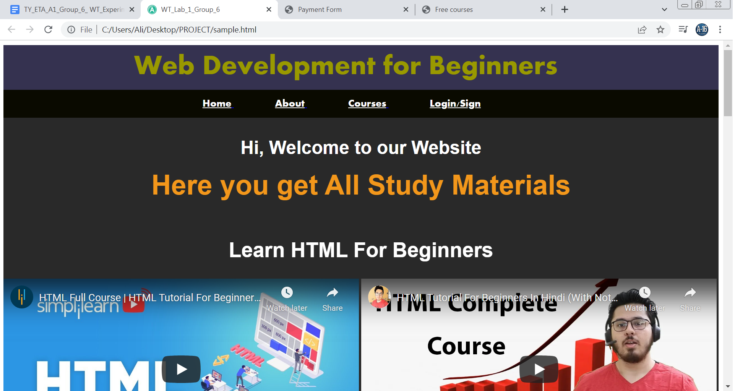

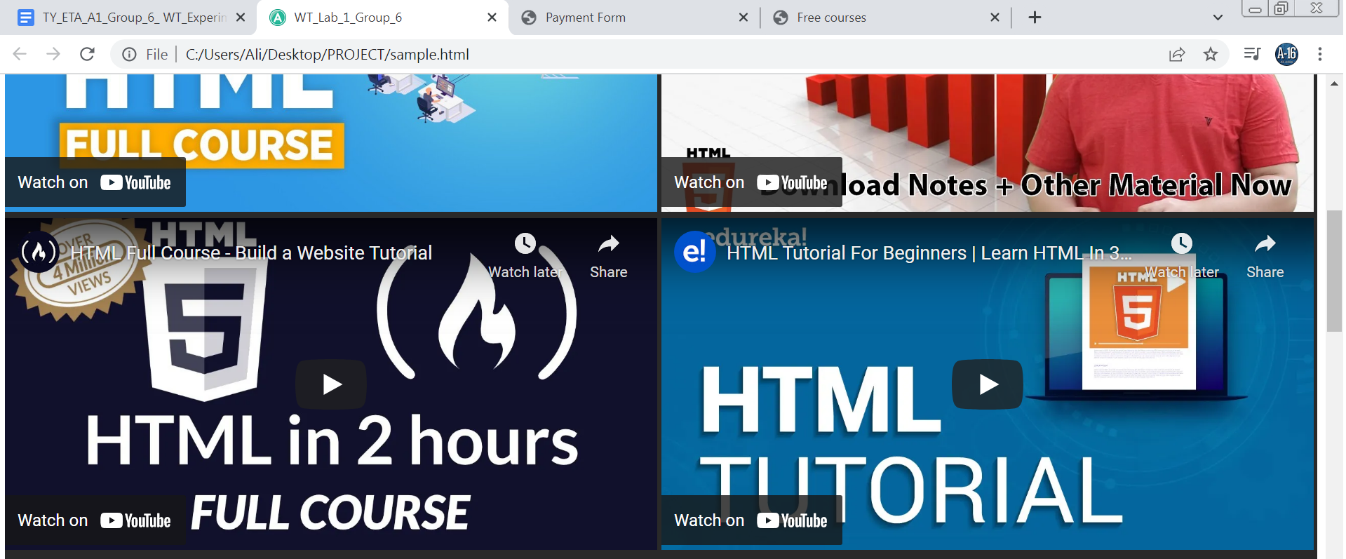

**2.** **Login page:**



****



